ADA PROJECT
Name: Suraj Kumar Yadav
School: SOET
Programme: BTECH CSE AI & ML
Section: C
Roll No: 24017300154
Date: 03/02/26

Faculty Name: Mrs. Vandana Mam

Question 1: Fibonacci’s Series
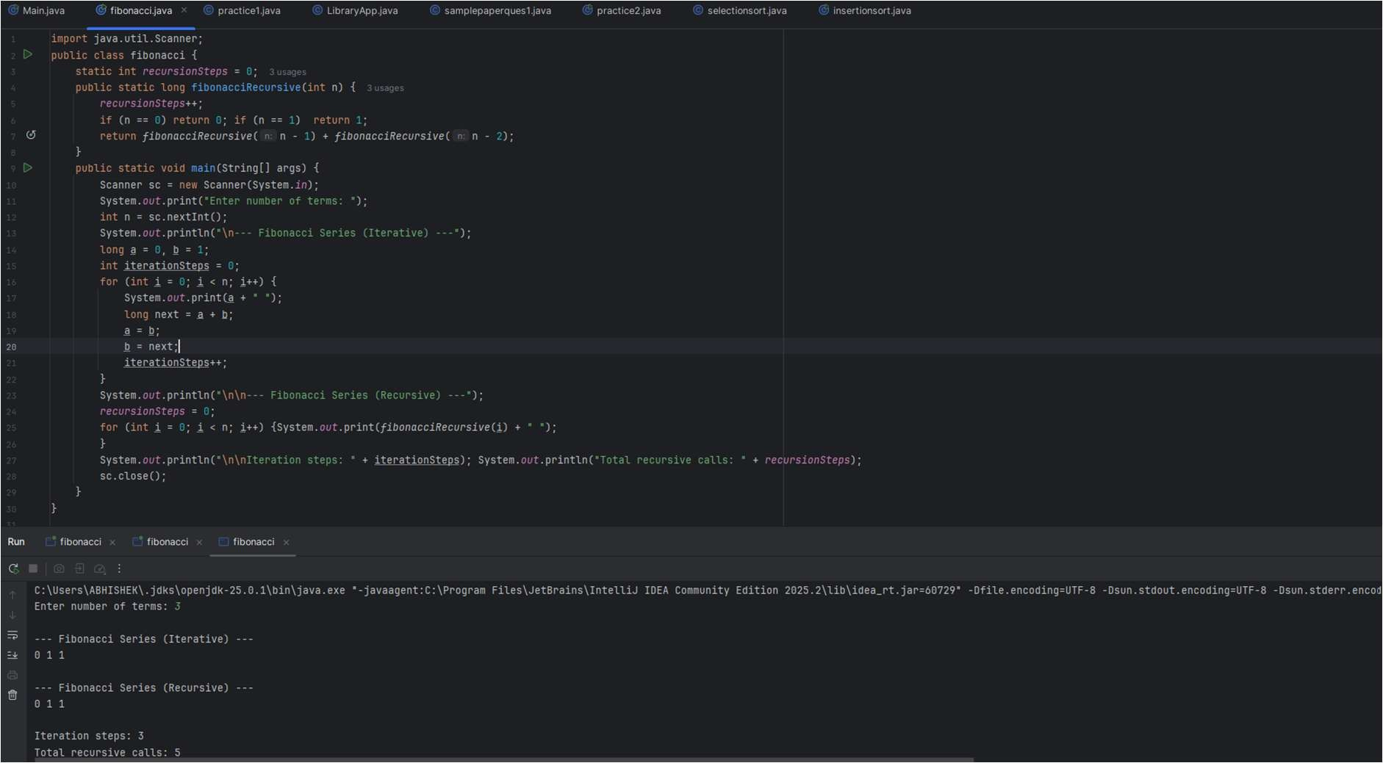

Question 2: Factorial Number:
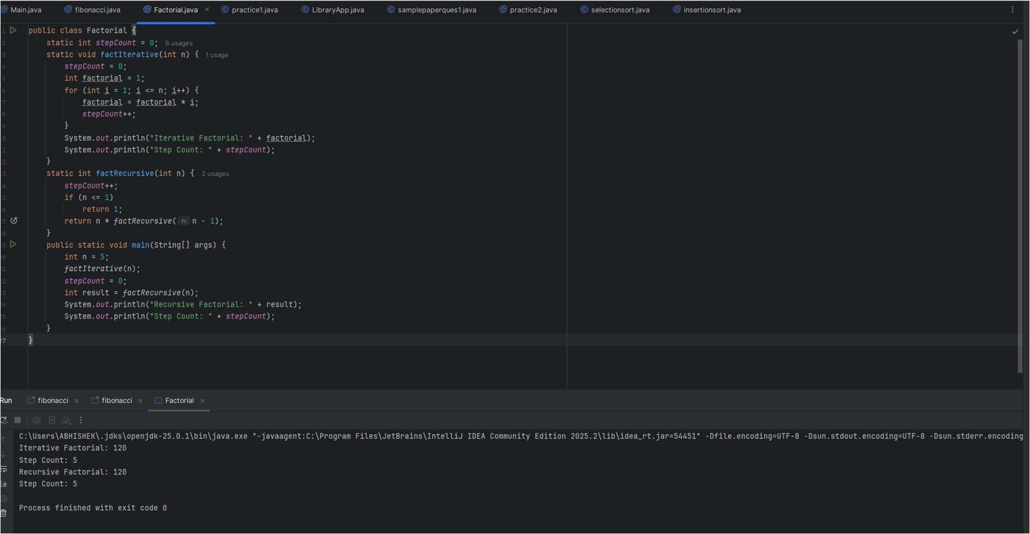
Question 3: Insertion Sort
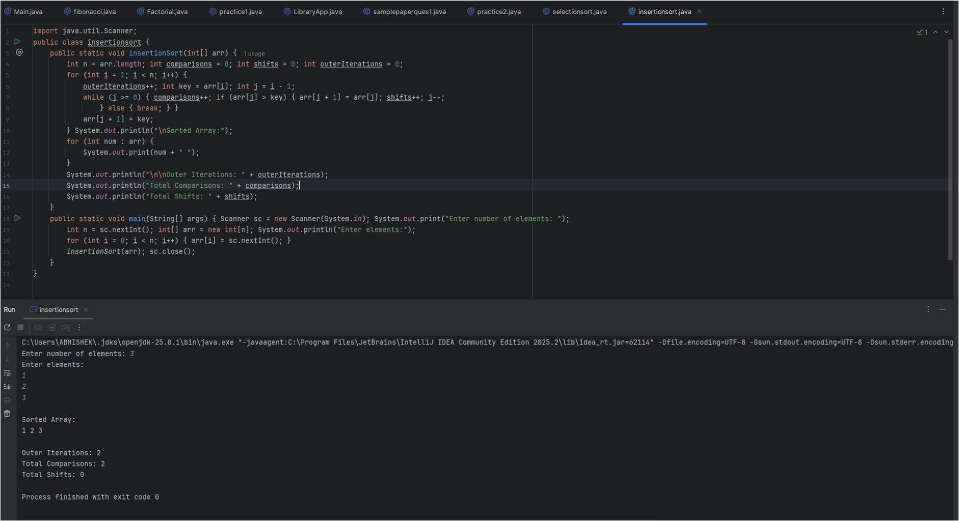

Question 4: Merge Sort
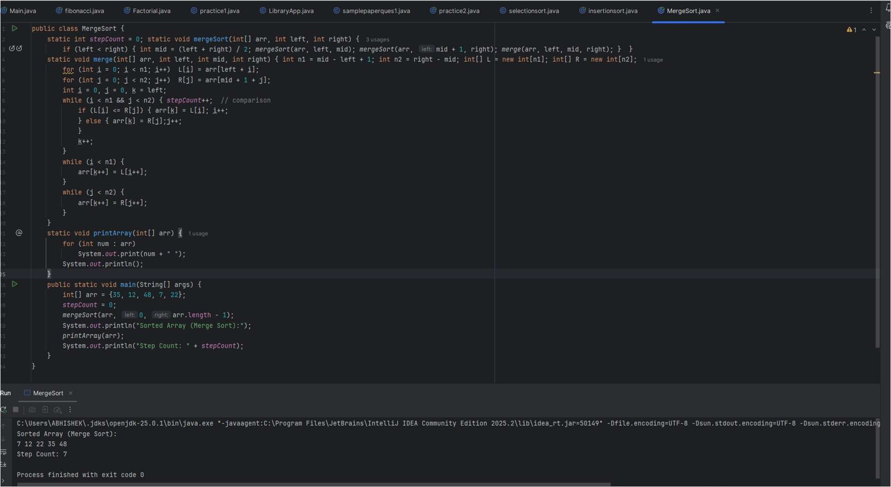
Question 5: Quick Sort
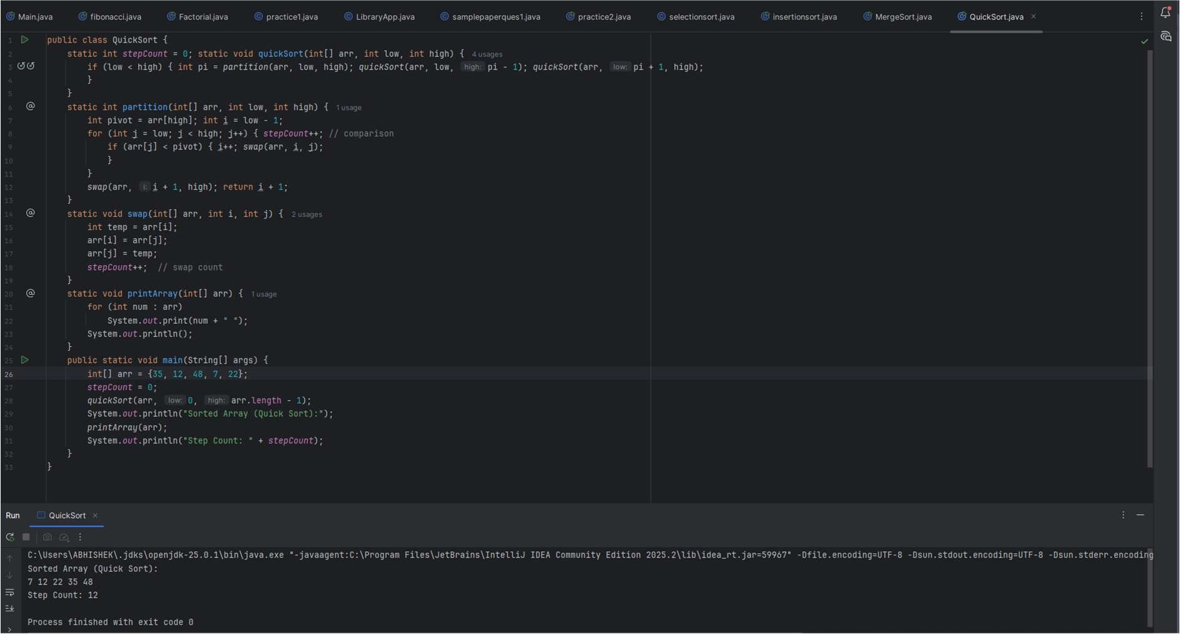

Question 6: Selection Sort
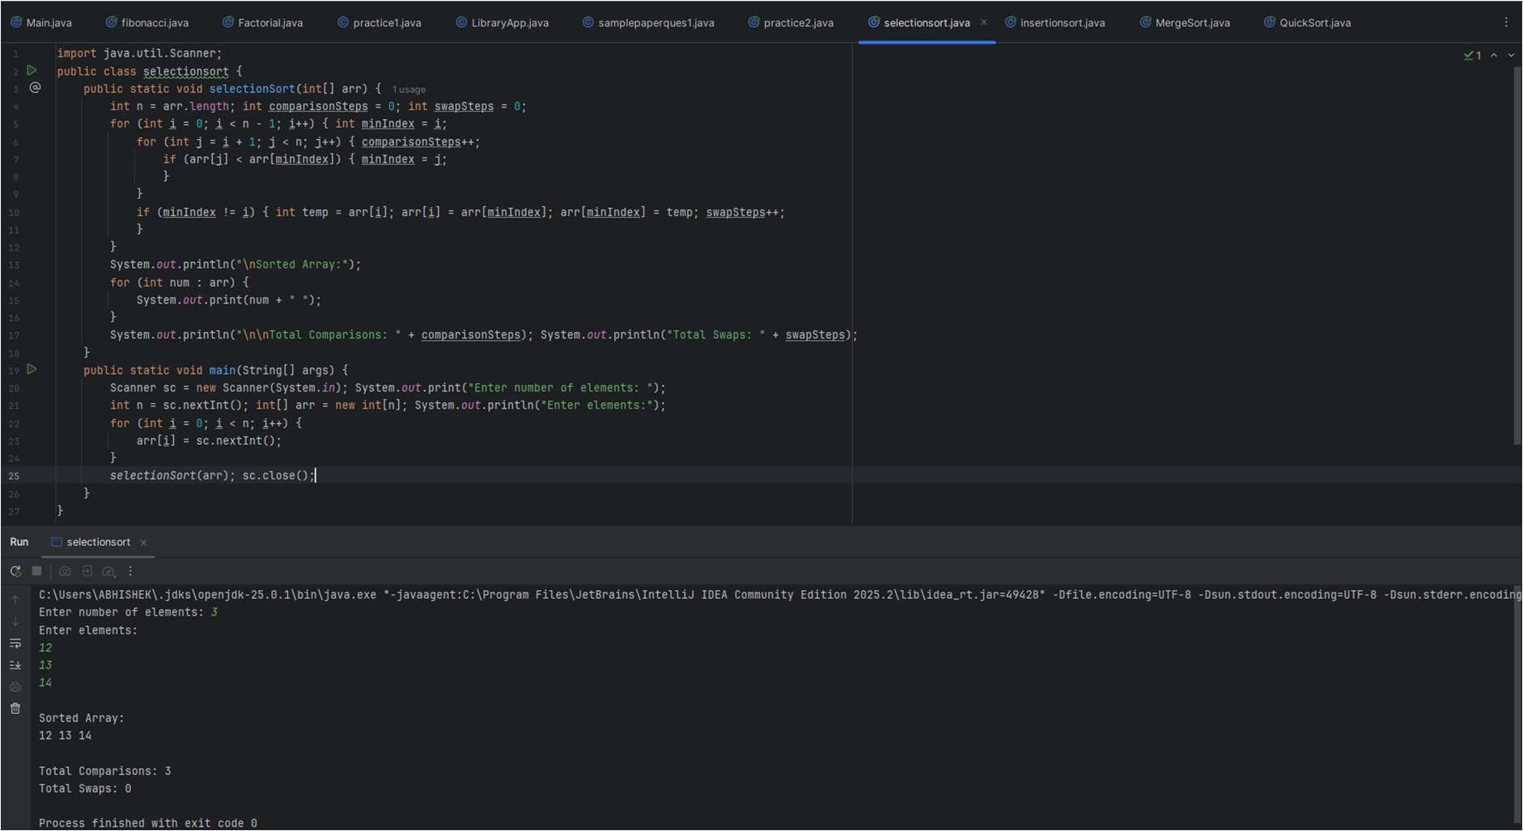
Question 7: Bubble Sort

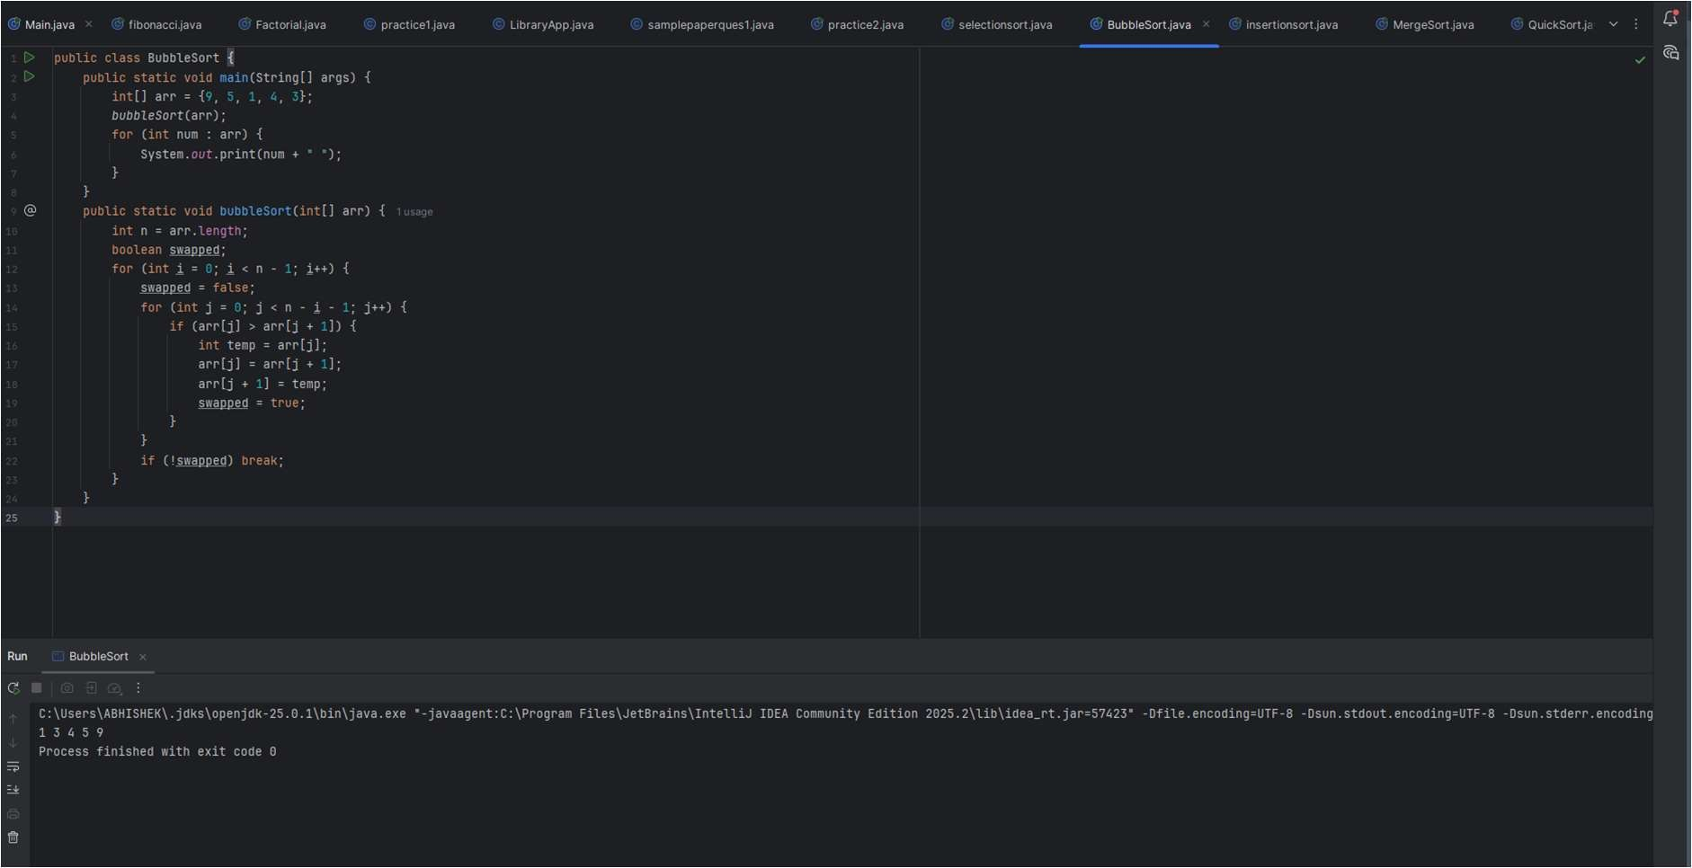

Question 8: Linear Search
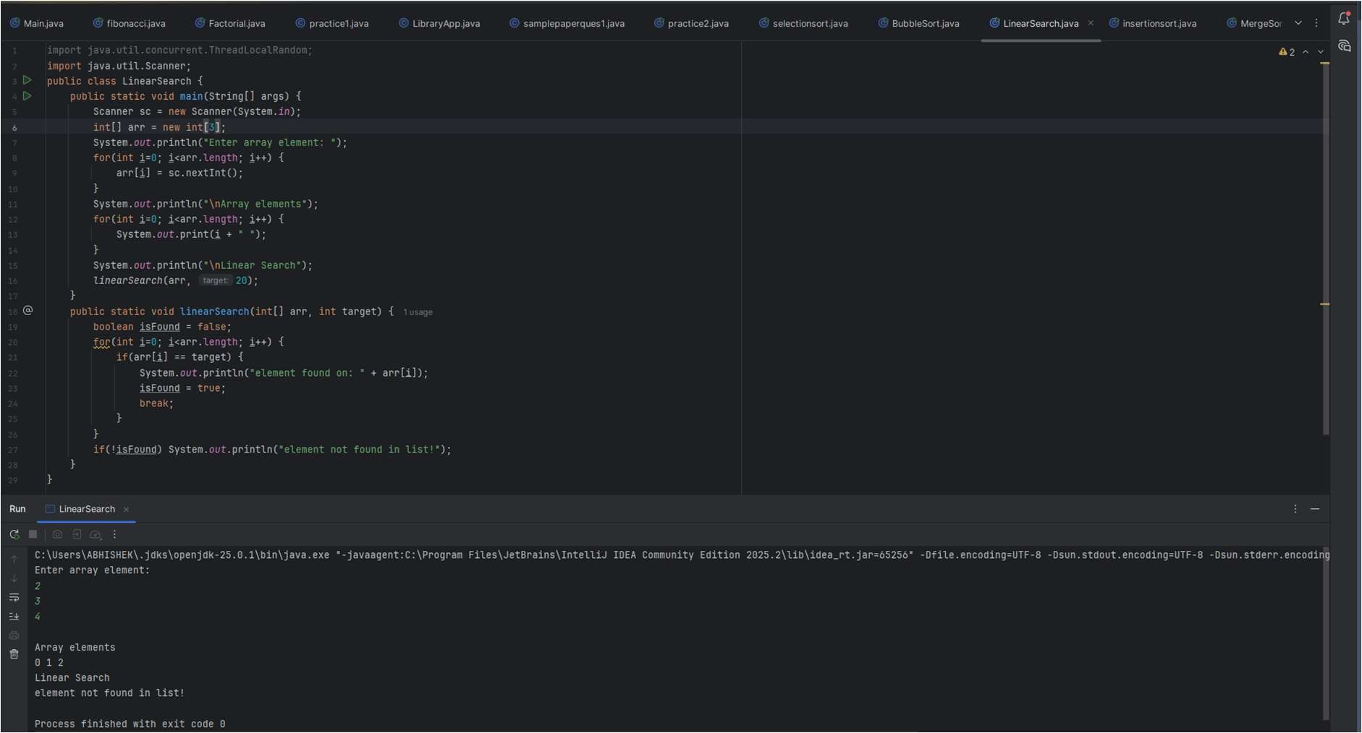
Question 9: Binary Search
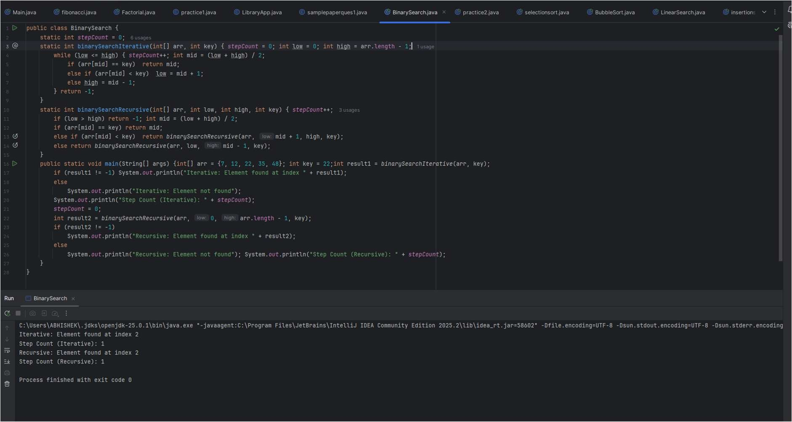

Question 10 : Bellman-Ford
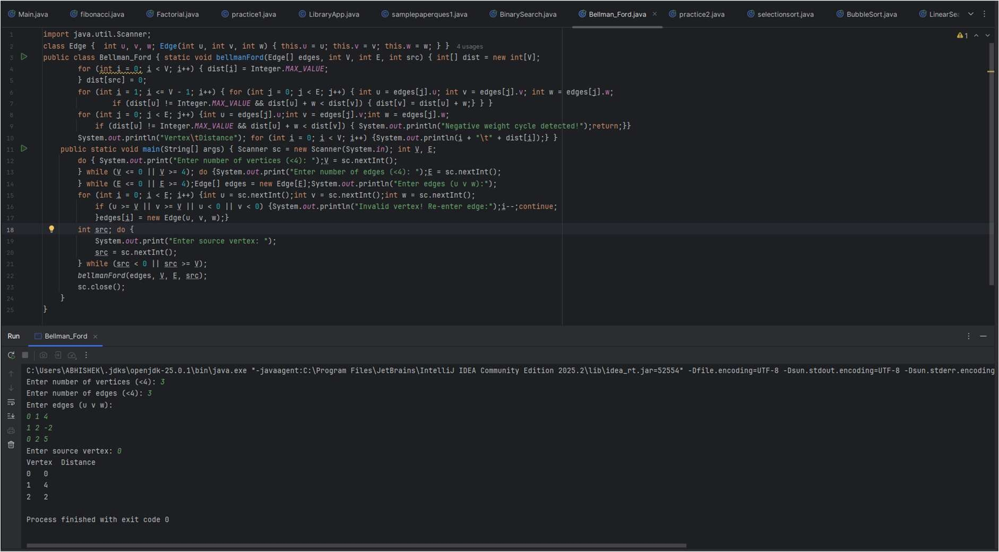
Question 11: Dijkstra Algorithm
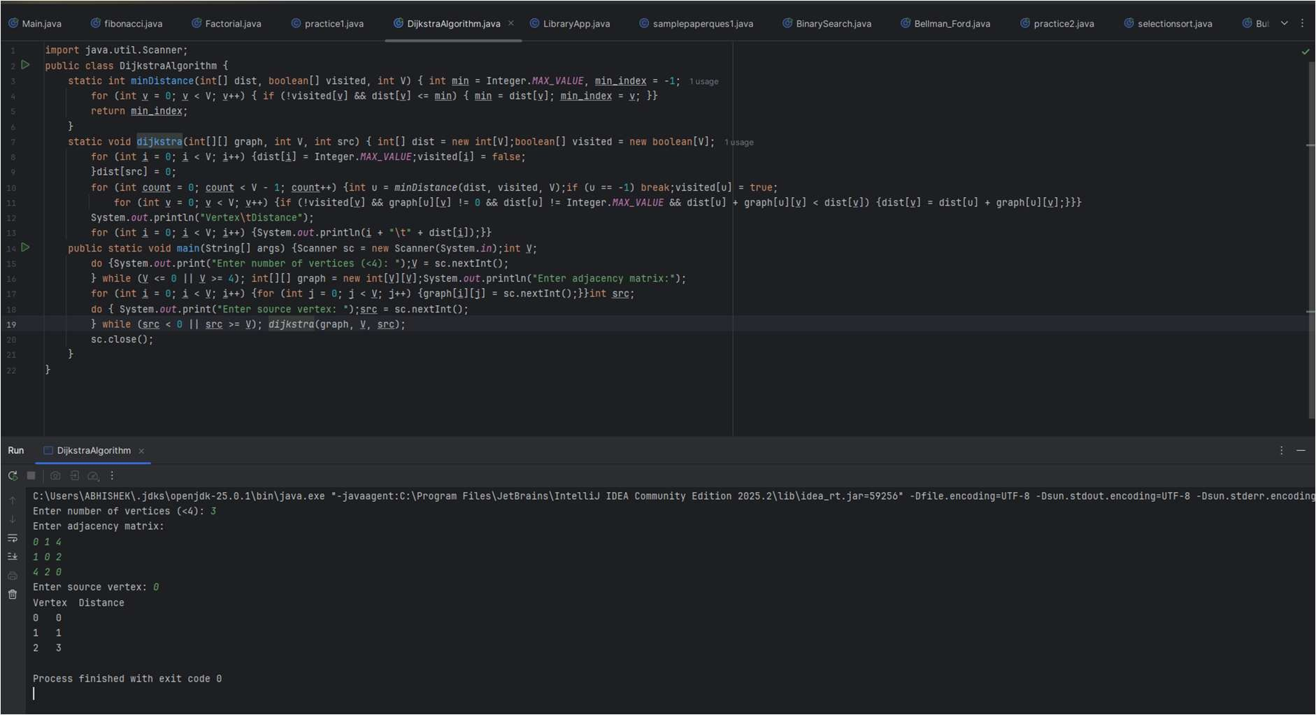

Question 12: Fractional Knapsack
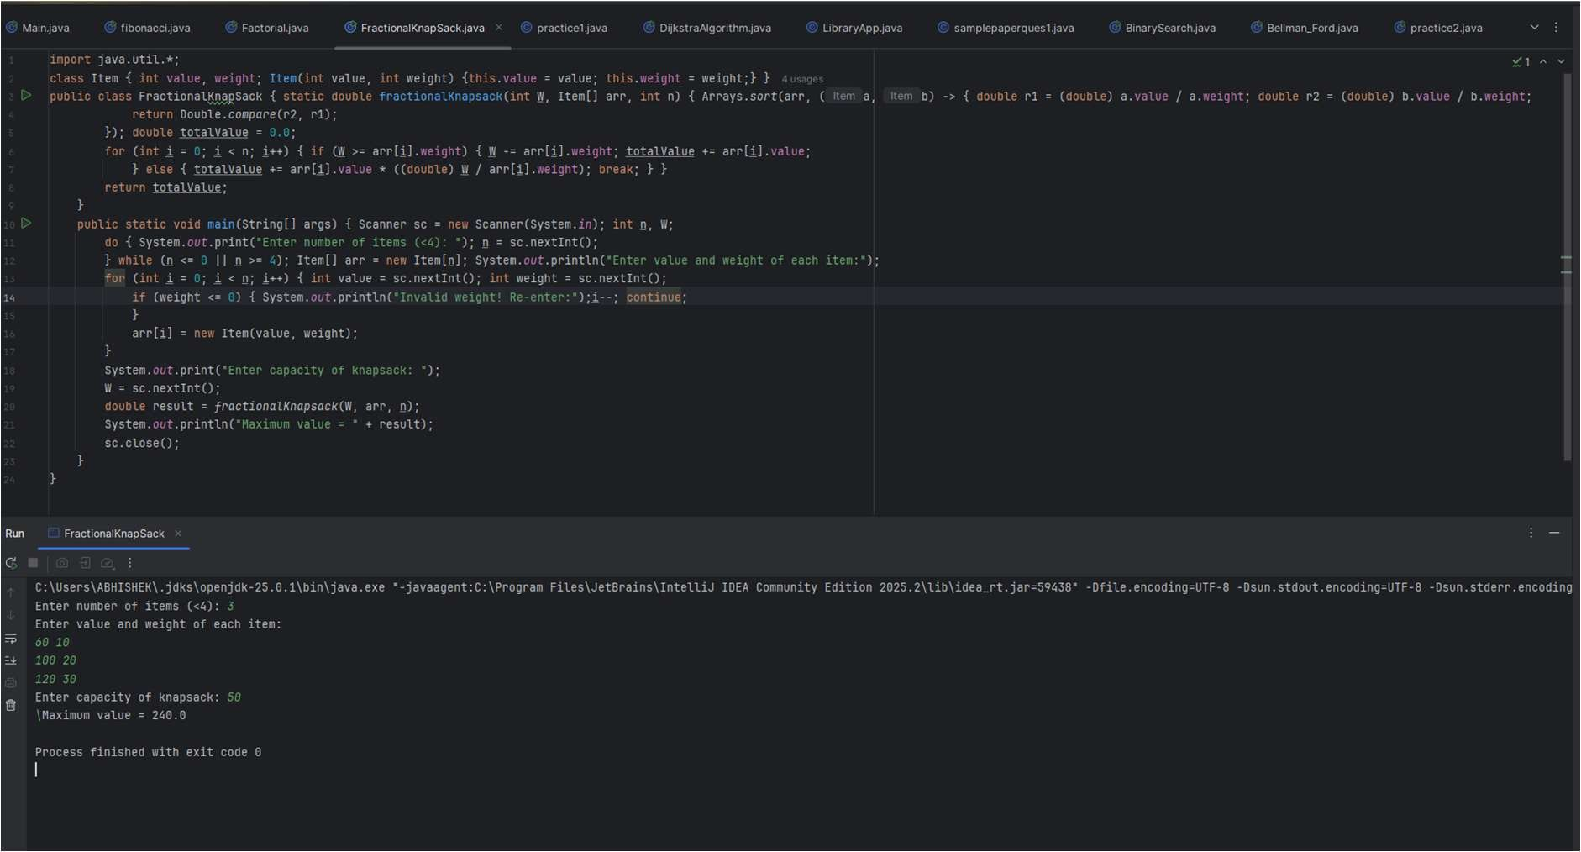
Question 13: Matrix Chain Multiplication
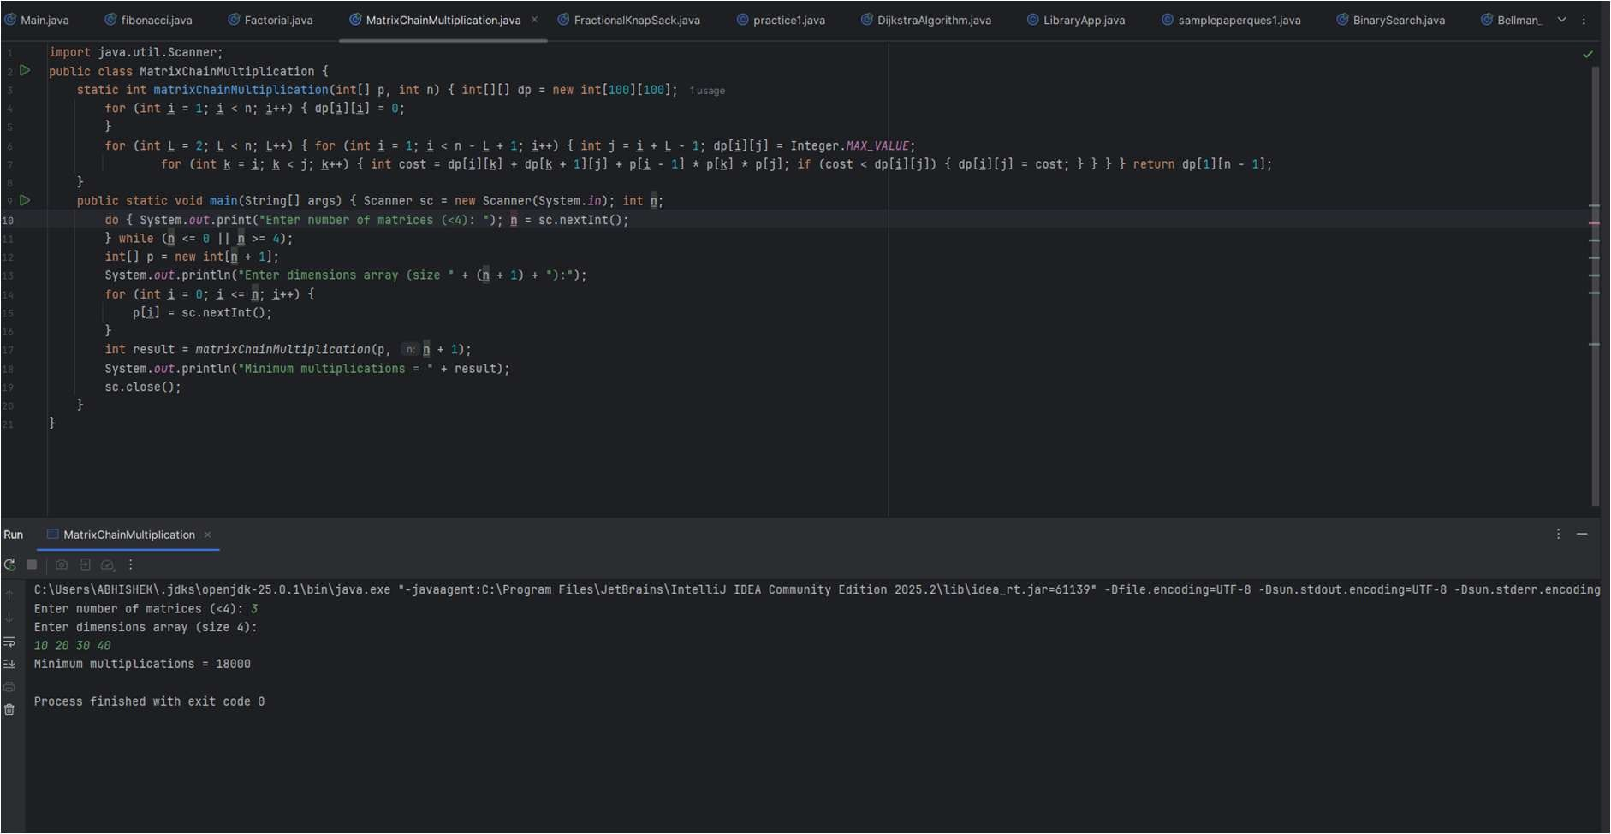

Question 14: Largest Common Subsequence
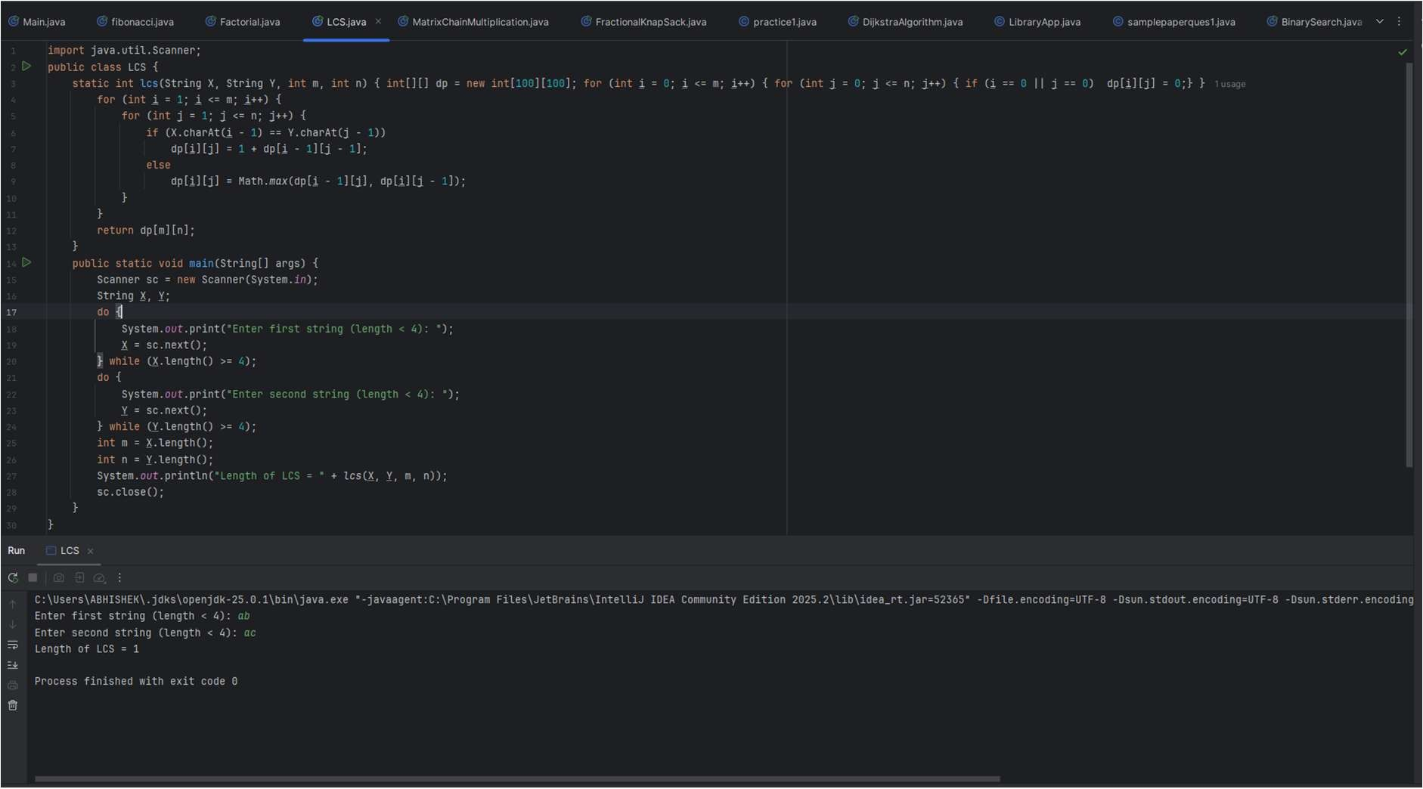
Question 15: 0/1 Fractional Knapsack
